The concept of safety has been the number one priority of the airline industry for the past 50 years. We have always strived to bring best in class experiences for consumers as well as providing them with the safest form of transportation. In today’s world flying has grown to become even safer, with the number of accidents significantly decreasing over the past 20 or so years. Looking at the data we know that airline travel is one of the safest forms of travel around and is safer than getting in your car.

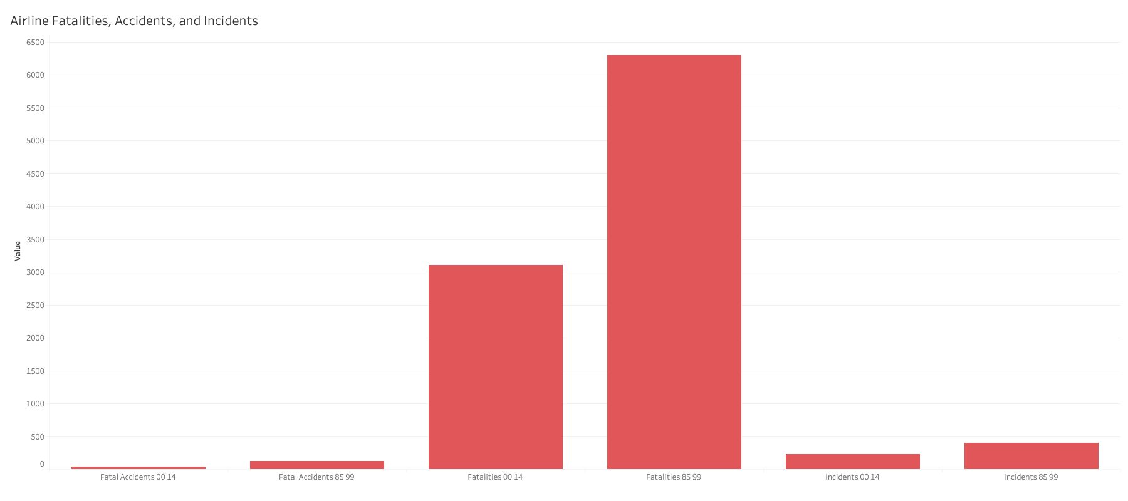

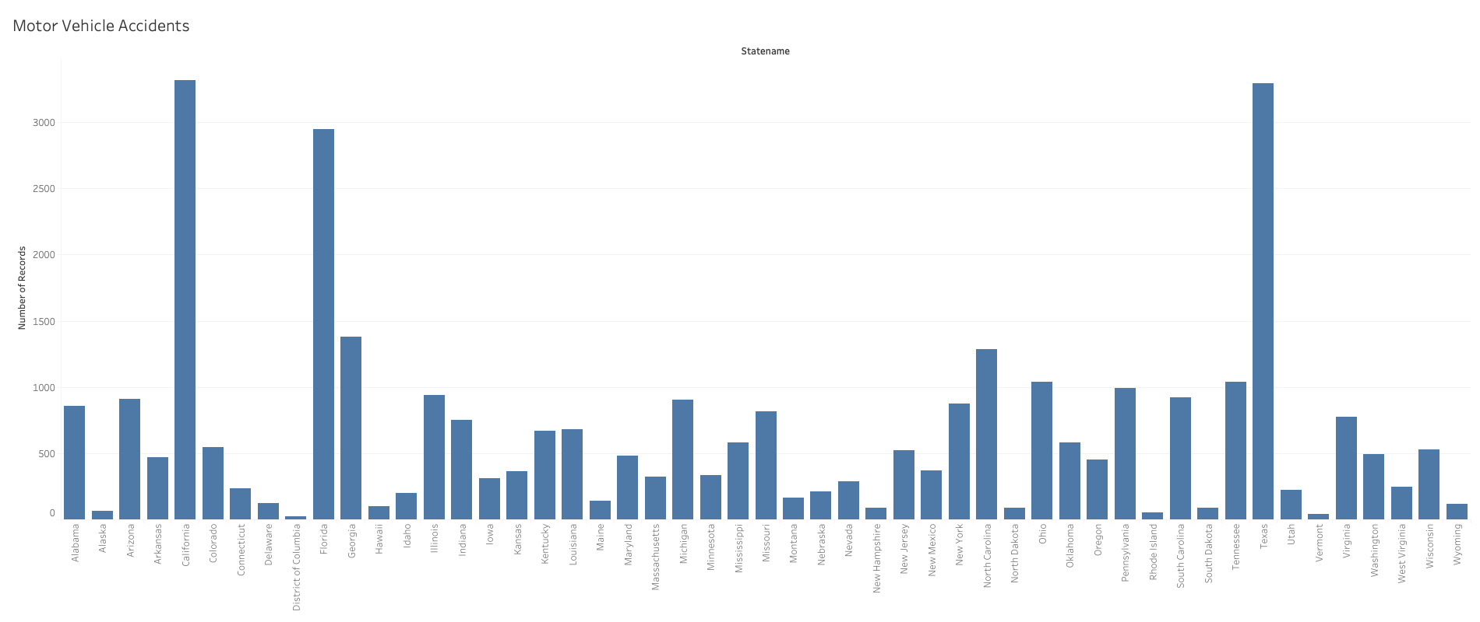

As you can see in the data above in 2019 alone, we saw a much higher rate of accidents in automobiles than we saw in airlines from 1985 to 2014. Thus, showing the immense safety of flight comparable to that of other ways to travel. "More than 38,000 people die every year in crashes on U.S. roadways. The U.S. traffic fatality rate is 12.4 deaths per 100,000 inhabitants" (ASIRT,2021). This rate is much higher than that of airline travel. In a worldwide scale we see an even higher rate of death by car accident. "Approximately 1.35 million people die each year as a result of road traffic crashes" (WHO). In the maps below you can see the deaths and fatal car crash results per state.

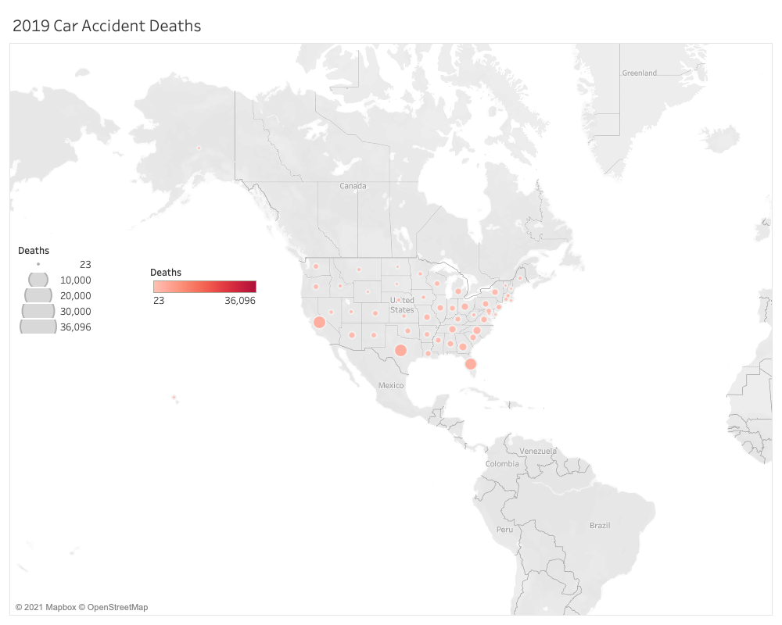

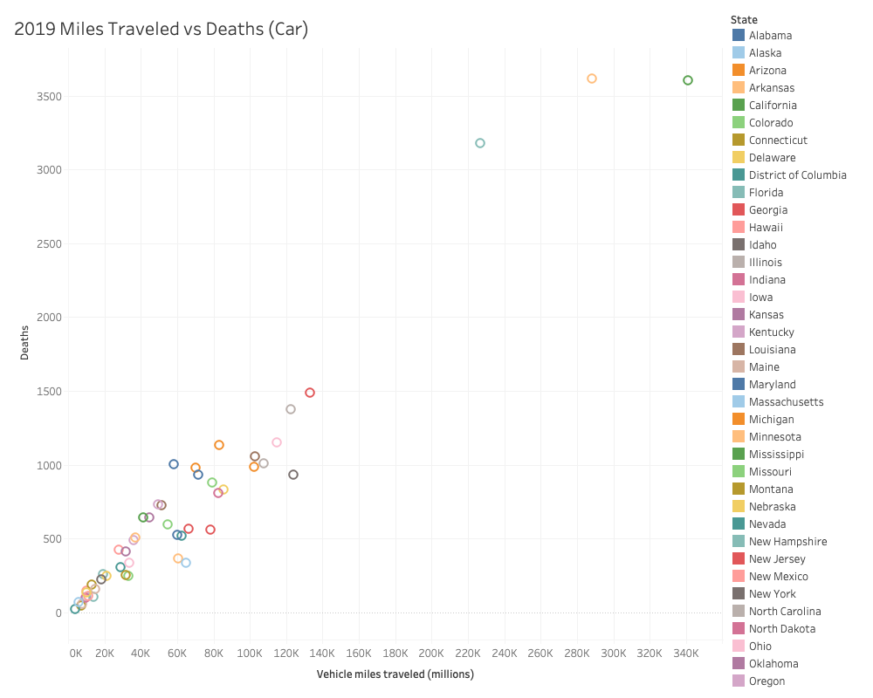

Over the years, airline accidents have decreased significantly compared to those of automobiles. Which shows that planes have gotten safer since their inception. This also considers that the number of planes has significantly increased as well as destinations to travel over the past 20+ years. Overall, as the number of flights has increased, we have seen a decrease in accidents, due to the fact planes have gotten safer.

Most accidents were caused in the early days of air travel. They no longer have the same risks as once were held. "Commercial scheduled air travel is among the safest modes of transportation; the 2018 lifetime odds of dying as an aircraft passenger in the United States were too small to calculate. Preliminary estimates of the total number of accidents involving a U.S.-registered civilian aircraft increased from 1,315 in 2017 to 1,347 in 2018. The number of civil aviation deaths increased, from 347 in 2017 to 393 in 2018. All but two of the 393 deaths in 2018 were onboard fatalities. One of these deaths involved a commercial airline" (Injury Facts,2020). Safety is the most important aspect of air travel, and we will continue to ensure your safety as we continue to grow.

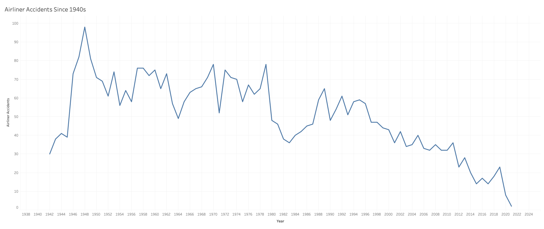

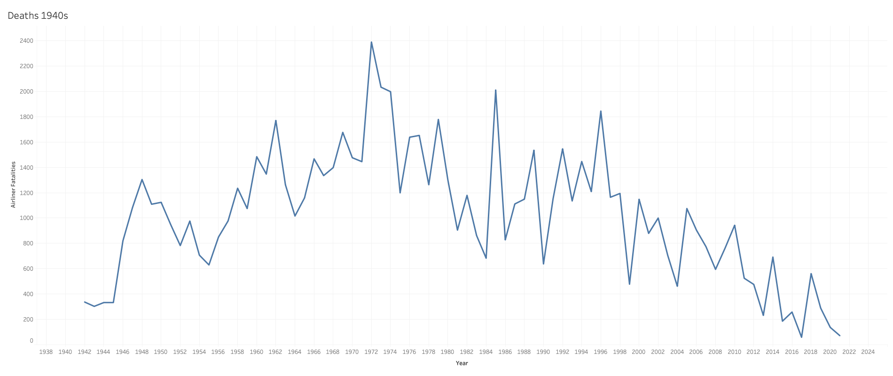

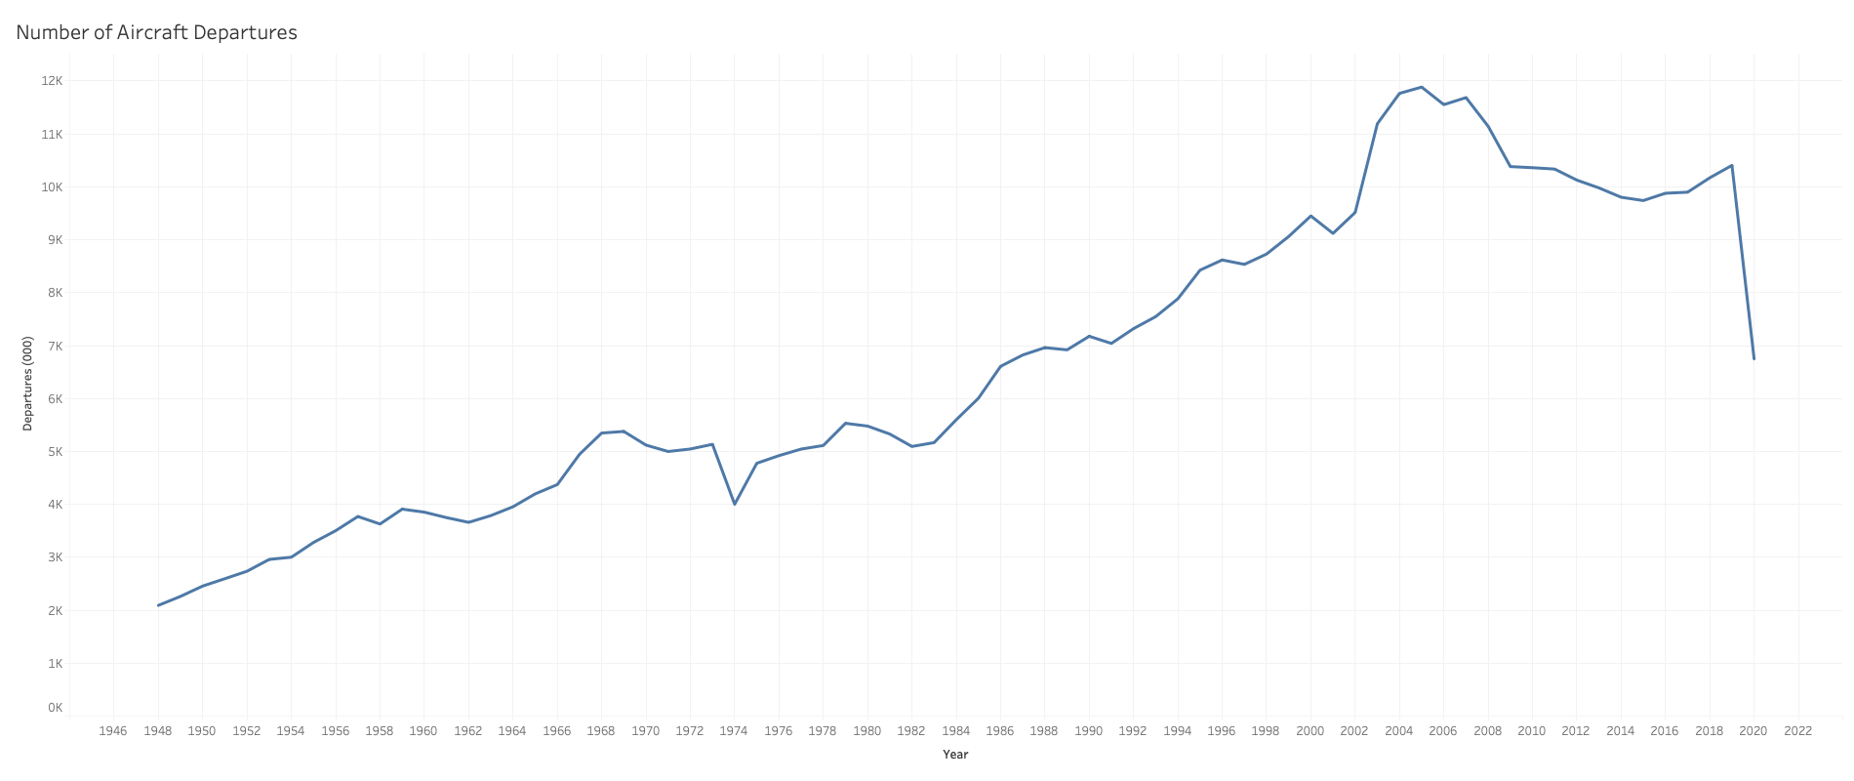

**References:**

**Airlines for America. (n.d.). U.S. Airline Traffic and Capacity.** [**https://www.airlines.org/dataset/annual-results-u-s-airlines-2/#**](https://www.airlines.org/dataset/annual-results-u-s-airlines-2/)

**Airplane Crashes. (2020, March 3). Injury Facts.** [**https://injuryfacts.nsc.org/home-and-community/safety-topics/airplane-crashes/**](https://injuryfacts.nsc.org/home-and-community/safety-topics/airplane-crashes/)

**Fatality Facts 2019: State by state. (n.d.). IIHS-HLDI Crash Testing and Highway Safety.** [**https://www.iihs.org/topics/fatality-statistics/detail/state-by-state**](https://www.iihs.org/topics/fatality-statistics/detail/state-by-state)

fivethirtyeight/data. (n.d.). GitHub. <https://github.com/fivethirtyeight/data/tree/master/airline-safety>

NHTSA. (n.d.). NHTSA. <https://one.nhtsa.gov/Data>

Q, A. (2021, April 19). Road Safety Facts. Association for Safe International Road Travel. <https://www.asirt.org/safe-travel/road-safety-facts/#:%7E:text=More%20than%2038%2C000%20people%20die,for%20people%20aged%201%2D54>.

Ranter, H. (n.d.). Aviation Safety Network > Statistics > By period. Aviation Safety. <https://aviation-safety.net/statistics/period/stats.php?cat=A1>

World Health Organization. (n.d.). GHO | By category | Road traffic deaths - Data by country. WHO. <https://apps.who.int/gho/data/node.main.A997?lang=en>